Integrating Customized Information Resources into Opera Online Help
In response to many requests from hotels and chains for a way to integrate access to their own support information from within the Opera online help system, a new link has been added to the Opera Help Contents panel — Customized Help.
After you have set up the required “portal” page as described below, selecting this link will open your customized help system in a new browser window. The portal page will be like a table of contents with hyperlinks to almost any customized corporate information resource you wish to make available, including MS Word documents, Adobe Acrobat PDF files, and HTML pages. (The user’s PC must have the appropriate application programs installed in order to display the types of files you wish to make available.)
Creating the portal page, as well as maintaining the information resources to which this page provides access, will be a hotel or chain responsibility.
Here are instructions for setting up the portal page.
1. Using MS Explorer, navigate to the micros/opera/production/OperaHelp directory on your application server. Under the OperaHelp directory, is a subdirectory called customized.
2. Using an HTML editing program (MS Word can also be used), create the portal page with hyperlinks to the resources you wish to make available to users. Linked documents can be stored directly in the customized subdirectory or in other locations on your server.
Note: Be sure not to accidentally delete this subdirectory or its contents when you install new Opera files.
A simple portal page created with MS Word might look like this:
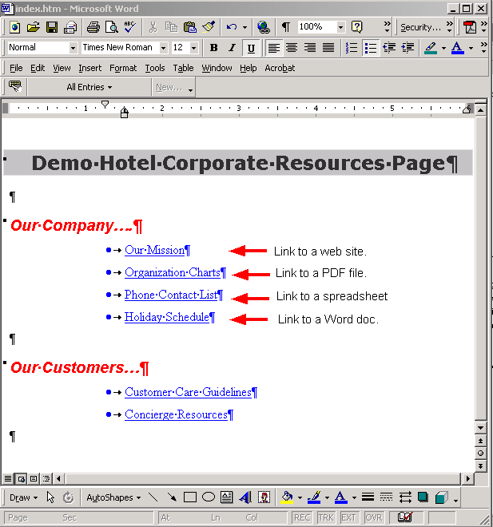
Save the page in HTML format with the file name index.htm. Place index.htm in the customized subdirectory.
As you update your resources, the linked information can be immediately available to your staff. To add or remove resources, simply edit your index.htm file.

